Teacher Work Sample: Polaris 1st Grade

Preston Gillis, Liz Griffin, Crystal Hinds

September to December 2016
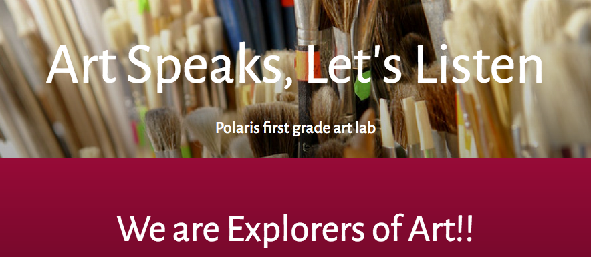

Enduring Understandings:
Artists utilize appropriate materials and techniques in order to convey components of themselves and the world around them. (materials and techniques)  I can use materials and methods to create art that’s about me. | Artists use images to communicate ideas and emotions connected to community and personal history. (history and culture)  Using art, I can show what I know about who I am. | Artists use reflection as a part of the art making process. (reflection and ideation)  I can learn from thinking about my art.
Learning Objectives:
Lesson Plan 1:  Given art materials SWBAT: design sketchbook cover using elements of their personal life effectively, through a variety of materials (Blooms: Make/ Standard: Create / GLE: Create art to communicate ideas, feelings, or emotions/ Art Learning: Expressive features and characteristics of art; NLT: sequencing)  Lesson Plan 3:  Given Acrylics, SWBAT create colors by mixing and using brush techniques to use in their future works. (Blooms: Create | Standard: Create | GLE: Create art to communicate ideas, feelings, or emotions | AL: Materials/Techniques; NLT: measurements/quantity)  Lesson Plan 3:  Given materials, SWBAT Create images inspired by their individual life experiences and thoughts. (Blooms: Create | Standard: Comprehend | GLE: Art represents and renders the stories of people, places, or things | AL: Elements/principles of art |Numeracy: repetition) | Lesson Plan 2:  Given prompts and through observation, SWBAT Create images from their surroundings, that communicate their observations.( Blooms: Create; Standard: Comprehend; GLE: Art represents and renders the stories of people, places, or things ; AL: multi cultural/historical content; NLT: repetition)  Lesson Plan 5:  Given materials, SWBAT transfer concepts into an artwork based on past artwork’s concepts and ideas. (Blooms: Create | Standard: Transfer | GLE: Visual arts relate experiences to self, family, and friends | AL: Expressive Features and characteristics of art, Historical/multicultural content | Literacy) | Lesson Plan 1:  Given information SWBAT: utilize sketchbooks by reflecting on how other artists use sketchbooks.. (Blooms: Applying/ Standard: Reflect/ GLE: Visual arts provide opportunities to respond to personal works of art and the art of others/ Art Learning: Critical reflection/aesthetics/transfer; NLT: communicating understanding)  Lesson Plan 2:  Given materials, SWBAT Recall a personal event and explain it through art making, using visual storytelling. (Blooms: Knowledge; Standard: Transfer; GLE: Communication through advanced visual methods is a necessary skill in everyday life; AL: Critical reflection; NLT: sequencing, storytelling )  Lesson Plan 2:  Given examples, SWBAT communicate through creative response about the art around them, effectively. (Blooms: Comprehension; Standard: Comprehend; GLE: Historical and cultural context are found in visual art; AL: Elements and Principles of art; NLT: critical thinking)  Lesson Plan 3: Shown an image of an artwork, SWBAT communicate what is visually being depicted through vocabulary such as repetition, texture, pattern and color. (Blooms: Understanding | Standard: Comprehend | GLE: Art represents and renders the stories of people, places, or things | AL: Critical reflection | Literacy)  Lesson Plan 4:  Using observational sketches, SWBAT plan to create a work of art, that tells a story. (Blooms: Planning; Standard: Comprehend; GLE: Art represents and renders the stories of people, places, or things; Art Learning: Conceptual/ideation/personal grounding; Literacy: story telling)  Lesson Plan 5:  With provided information, SWBAT recognize and evaluate the difference between a 2D and 3D form by discussing the various features. (Blooms: Understanding | Standard: Transfer | GLE: Identify and discuss ways to express ideas in creating works of art | AL: critical reflection/aesthetics | Literacy | concept)  Lesson Plan 5:  Using finished work, SWBAT Explain intention in their’s art other student’s art by discussing art making decisions. (Blooms: Evaluate | Standard: Reflect | GLE: Critique personal work and the work of others with informed criteria | AL: Critical reflection | Literacy | Reflection)

Our unit topic:

In Julie 's first grade class we chose Communication for our unit focus. Visual art is a form of communication, we communicate about ourselves, our environment, and our experiences. Through a variety of materials we will explore how art communicates our intentions. We will touch on communicating through visual stories and movement as the lessons progress. Moving through the unit lessons the students used a variety of art materials and processes like painting, clay building, paper and found objects as well as drawing and large scale sculpture techniques. In their own ways each student was able to experience communication through multiple mediums, which inspired creativeness and innovation in their peers.
We began with the notion of using art to tell a story, to share who we are through what we make. This concept still holds true, there’s just been minor aspects that have been added, such as observation and technique. Artists tell stories through their art. They translate their thoughts, emotions, and ideas into visual imagery. This was a large part of what we concentrated on. “What do you want to make, and how can you make that happen?” We started general with learning about detail and observation, then took that learning and lead into more specific lessons, such as creating clay creatures. Most of these lessons were spent over two/three days, which taught that art takes time. It takes time and it can be altered. An artist’s concept can start as one thing and grow into something else!

In the first lesson:
Our first graders were encouraged to create a story about themselves on their sketchbook, we played the name game and talked about Discoveries. Getting to know you was an introductory lesson designed to step into art making and get to know our first graders by laying the foundation for a strong and purposeful relationship. During this lesson the crew was able to consider what they could say through visual art to another person to introduce themselves. Using familiar materials the crew was eager to express themselves.
Being that our first class was geared towards getting to know our first graders. We began our lesson by introducing ourselves along with the art that we make, explaining what inspires us/why we create art. We then discussed the importance of discoveries in making art; asking, “have you ever made a discovery about anything, if so, what was it? What can we do with these important discoveries? Can we put them in our pockets?” This lead into our power point about sketchbooks. We explained how we can store our ideas/discoveries in sketchbooks, and how the use of sketchbooks is an exercise for our brain. After creating our covers, We then went around and asked what everyone had discovered and wrote it on a sticky note. At the end students shared their discoveries and added their sticky to the discovery board.

In the second lesson day 1:

We learned that artists use their sketchbooks to record ideas and what they observe. Students also built and used a pair of binoculars or a telescope to help them look at and observe their surroundings. We learned that we can look at the world around us, and through observation we can make art. We can record what we find (our observations) in our sketchbooks for future ideas and works.
During class, we first built our binoculars or telescopes, then we used them to observe our surrounding in different ways. We looked at things close to us, and sketched what we could see. We looked at things that were farther away from us, across the room or outside, and sketched what we could see. Then we used our imagination and our binoculars to imagine a new thing to sketch. These activities will feed into our future days of this lesson. Learning how to look in different ways allows artists to use different perspectives.

In the second lesson day 2:

We continued the skill of observation. In the beginning, we went over what details are and how we can find them. We started with asking what a detail is, and how do you know. Students responding with phrases like, “it’s something small that makes a bigger thing.” Based off of their answers, we then asked them to point out what detail they could observe in a poster of a Japanese woodcut that was displayed. Our co-teacher brought arrows to stick on to the poster and make visible their observations of detail.

The rest of the day was spent observing and recording details. The crew was asked to find four details in their poster and record them in a note catcher in their sketchbook. We also incorporated a color mixing activity for the remainder of class. Students had the opportunity to create the colors that they observed in the posters. It was mostly experimental, and allowed them to discover through play.

In the second lesson day 3:

We continued with our work in details by painting a story. To help us relate how a story includes details we read “Rocket writes a story.” It is a story about a dog that discovers words or details and decides to write a story using those words. We have been looking at different works of student art and posters to discover and understand what details are and what their purpose is in a work of art. Through exploration with different ways of looking/seeing, mixing colors and finding/drawing specific details we have found all the elements necessary to paint a story. We applied this idea to painting a story without words. Students were prompted to pull from the images and colors that they observed from last time,as well as prior experiences to create their own “painted story.”

The third lesson day 1:

We introduced a new material: clay. The crew were encouraged to play with clay and discover its qualities without prior instruction. This type of exploration is crucial to understanding how the material works and what is possible working with it. After this, each teacher gave a mini lesson to groups about clay techniques; slipping and scoring, making a pinch pots and different shapes. We stressed the importance of making a clay piece durable.

The third lesson day 2:

The class was focused around creating a clay creature. We began by introducing the concept of a creature, and all of the animal aspects that could be included. “Does your creature have scales, fur, or feathers?” “How does it move?” Students spent time coming up with these crazy creatures and drawing their plan in their sketchbook. Students explored literacy in art by considering what attributes their creatures could have.

The third lesson day 3:

The class was spent expanding on clay techniques and revisiting the theme of details. We wanted to be sure the attachments were strong, as well as add details to our pieces. Students experimented with several tools to make texture. We asked the crew what they wanted to do next with their creatures. The crew voted to make habitats. This created our lesson of building habitats for our creatures.

The third lesson day 4:

We learned about how qualities of an animal or person affect their habitat, or where they live. We modeled what we were doing for the day with an example creature, and made a habitat as a group. “This creature likes to sit in the shade, so let’s create a tree!” Other thoughts such as a bed, a friend for the creature, its food were incorporated. Each student made their own small habitat designed for their creature. This emergent style lesson allowed our crew to feel confident in their making and really explore their ideas. Creating opportunity to allow their ideas to evolve and become somewhat complex.

The third lesson day 5:

We explored pattern and how it affects how we identify objects. The crew used their new knowledge about patterns to finalize their creatures. Knowing how clay goes from work stage to paint stage is an important part of understanding process. To impart this information to the crew we presented a short presentation covering what a kiln is and how it “fires” the clay. In the presentation we also introduced the concept of patterns and what pattern could be. Asking the crew “What is a pattern?” “How do you know?” “ What do you think the purpose of patterns is?” The crew ideated together in small groups several different types of patterns and recorded those patterns in their sketchbooks. Then we worked on using one favorite pattern for finalizing our creatures. The crew used paint, feathers and fur to create their final surface treatments for their creatures.

The third lesson day 6/Final working lesson:

Today we introduced the concept of review and revision. For most students the lessons went a little quickly and some desired more time to work on their pieces. This day was designed to do just that. We talked about how most artists review and revise their work as they are working on it, but also may do a review and revise after they have finished a piece. The students worked productively on the pieces that they chose to revise.

PGC’s
- Recognize, articulate, and debate that the visual arts are a means for expression

- Make informed critical evaluations of visual and material culture, information,and technologies

- Analyze, interpret,and make meaning of art and design critically using oral and written discourse

- Recognize, demonstrate, and debate philosophic arguments about the nature of art and beauty (aesthetics)

- Recognize, demonstrate, and debate the place of art and design in history and culture

- Use specific criteria to discuss and evaluate works of art

- Recognize, articulate, and implement critical thinking in the visual arts by synthesizing, evaluating, and analyzing visual information

- Recognize, interpret, and validate that the creative process builds on the development of ideas through a process of inquiry, discovery, and research

- Develop and build appropriate mastery in art-making skills using traditional and new technologies and an understanding of the characteristics and expressive features of art and design
INSTRUCTION AND MANAGEMENT

Introduction to Unit
In Julie 's first grade class we chose Communication for our unit focus. Visual art is a form of communication, we communicate about ourselves, our environment and our experiences. Through a variety of materials we will explore how art communicates our intentions. We will touch on communicating through visual stories and movement as the lessons progress. Moving through the unit lessons the students used a variety of art materials and processes like painting, clay building, paper and found objects as well as drawing and large scale sculpture techniques. In their own ways each student was able to experience communication through multiple mediums which inspired creativeness and innovation in their peers.
We began with the notion of using art to tell a story, and to share who we are through what we make. This concept still holds true, there’s just been minor aspects that have been added, such as observation and technique. Artists tell stories through their art. They translate their thoughts, emotions, and ideas into visual imagery. This was a large part of what we concentrated on. “What do you want to make, and how can you make that happen?” We started general with learning about detail and observation, then took that learning and lead into more specific lessons, such as creating clay creatures. Most of these lessons were spent over two/three days, which taught that art takes time. It takes time and it can be altered. An artist’s concept can start as one thing and grow into something else!

Polaris first grade unit plan

Methods for Integrating Literacy, Numeracy, Technology, and other Components -
The role of technology in the art classroom is one that we, as teachers, are always working to understand, in order to wield it in a meaningful way. We try to use technology in the art classroom to maximize time and learning. A Powerpoint, if composed thoughtfully, can be much more than a slideshow. It can be used as an anticipatory set, activate prior knowledge, show reference pictures, slides can show steps and processes. The key to a powerful presentation is knowing your audience and knowing how your audience learns best. At Polaris we used Powerpoints that had a ton of animations, easy to read text, and colorful images. With this age group, the time we have to lecture is limited to around five minutes and a slideshow can present information visually and slides can be revisited easily.
Literacy is a life skill so whenever we have the chance to cultivate that we seize the opportunity. Every lesson we would introduce some new vocabulary words that are related to the materials and the learning target. First graders are aspiring readers and it is our goal to help develop their literacy skills. We brought a book that is about crafting a story. Literacy is not limited to just reading and writing; speaking and listening are also critical life skills. Learners had a chance to share their reflections with the class and this helped cultivate listening and speaking. We would ask probing questions to get students to dig deeper with their response. Reading, writing, listening and speaking was just as important as working with numbers.
It has been said that a day without math is like a day without sunshine we wanted to be sure that the sun was constantly shining on our class. Each lesson had inherent features of numeracy. For example, our Painting Patterns on Clay Creatures made students consider scale and proportion; as well as sequencing, ordering, creating, and recognizing patterns. Before students could paint their pattern they had to create three different patterns before painting.
A thoughtful art experience needs to have art learning as well as learning about technology, literacy and numeracy.

Classroom Management Strategies related to Instruction -
Throughout most of our lessons we incorporated different strategies both in the classroom and in our planning. As our students are younger and still learning how to be in school, we really needed to think about transitions. Incorporating activities or work breaks into the flow of the lesson allowed students to move from one task to another minimizing disconnect. One such example is our discovery board. During the lesson we would write discoveries down as we heard them and at the end we would allow students to state their discovery and put it in their board pocket. This activity was a closure to our class time and allowed them to transition to recess. Another technique that we incorporated into our lessons was greet and review with targeted questions. This technique could be used either at the start of class or at the close of class. Reviewing information or techniques that we used in a previous class helped the students to get into the art mindset before starting class. This approach also served as a formative pre-class and post class assessment.
Putting the learning into the hands of the student is very important, in this regard we incorporated activities for reflection such as turn and talk, group huddle, and voting for the next project. During one of the lessons a student made a discovery that we felt would benefit the whole class so we had them demonstrate their technique for the class. Clean up can sometimes be a bit chaotic if you do not have a plan. At first, we were not sure how to handle clean up so we mostly did it. It became clear after the second lesson that the students were willing and able (and some needed to) help clean up. We assigned jobs for students to complete during clean up so that everyone was doing something that would move us to reflection time. For one of our students it was very important that he was engaged in a job or activity that allowed him to get up and move. Management infused in instruction takes practice, and there are many ways to incorporate specific management tools into your instruction. We have learned a lot about this practice during our experience with the Polaris lab students.

Lesson Plans and Documentation
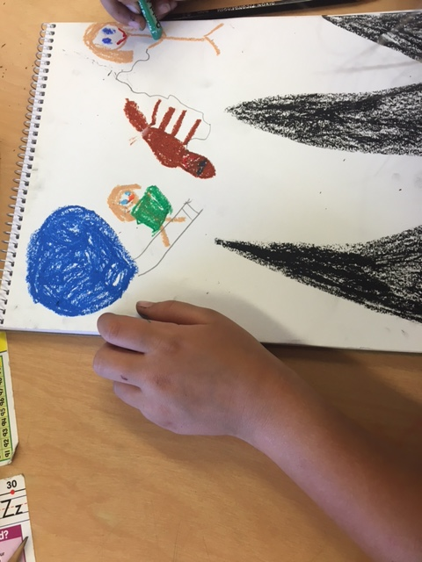
In the first lesson, Our first graders were encouraged to create a story about themselves on their sketchbook, we played the name game and talked about Discoveries. Getting to know you was an introductory lesson designed to step into art making and get to know our first graders by laying the foundation for a strong and purposeful relationship. During this lesson the crew was able to consider what they could say through visual art to another person to introduce themselves. Using familiar materials the crew was eager to express themselves.
Being that our first class was geared towards getting to know our first graders. We began our lesson by introducing ourselves along with the art that we make, explaining what inspires us/why we create art. We then discussed the importance of discoveries in making art; asking, “have you ever made a discovery about anything, if so, what was it? What can we do with these important discoveries? Can we put them in our pockets?” This lead into our power point about sketchbooks. We explained how we can store our ideas/discoveries in sketchbooks, and how the use of sketchbooks is an exercise for our brain. After creating our covers, we then went around and asked what everyone had discovered and wrote it on a sticky note. At the end students shared their discoveries and added their sticky to the discovery board.
Lesson Plan 1
Documentation of Lesson 1 learning: https://artspeaksletslisten.wordpress.com/lesson-1/
In the second lesson, we intended for the students to explore details and new ways of seeing. We designed a three-part lesson that built up to the students creating their own painting. Part one was designed to encourage the students to look for details in artworks of others. We engaged them in a tool building exercise to help them look at the posters, and record their findings. Part two was utilizing their understanding of details in order to use paint as a vehicle of expression. They created a painting for the final step as a composite of the first and second step.

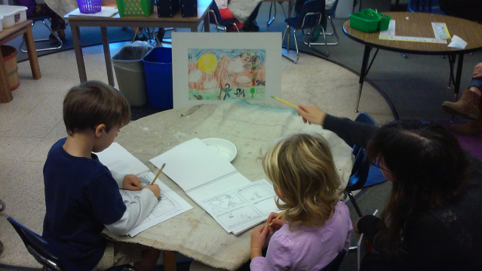

Lesson Plan 2

Documentation of Lesson 2 learning:
Day 1: https://artspeaksletslisten.wordpress.com/lesson-2-compare-and-contrast-imagination-vs-reality/
Day 2: https://artspeaksletslisten.wordpress.com/lesson-3-what-do-you-see-learning-observation-and-recording__trashed/lesson-three-what-do-you-seeseptember-23-2016/
Day 3: https://artspeaksletslisten.wordpress.com/lesson-four-september-302016/

In the third lesson, we spent time exploring clay, and the techniques that are used in clay working. We emphasized the possibilities of 3D form, texture, and pattern. Over five days, an exploration of clay emerged into creating individual manifestations of their imagined worlds. Students created clay creatures and habitats for those creatures, each with their own individual personalities, abilities, aesthetic qualities, etc.

Lesson Plan 3
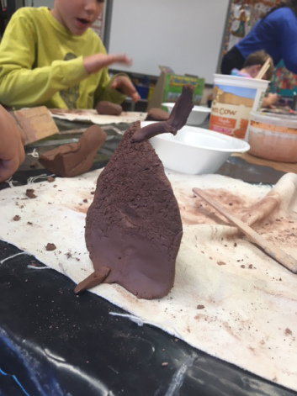

Documentation of Lesson 3 Learning:
Day 1: https://artspeaksletslisten.wordpress.com/lesson-five-october-72016/
Day 2: https://artspeaksletslisten.wordpress.com/lesson-six-october-21-2016/
Day 3: https://artspeaksletslisten.wordpress.com/lesson-seven-october-282016/
Day 4: https://artspeaksletslisten.wordpress.com/lesson-eight-november-4-2016/
Day 5: https://artspeaksletslisten.wordpress.com/lesson-9-patterns-and-painting-november-18-2016/
Day 6: https://wordpress.com/pages/artspeaksletslisten.wordpress.com

ASSESSMENT, UNDERSTANDING, AND REFLECTION

Student Pre-Assessment and Post-Assessment Analysis

PSD Growth Assessment for Elementary Art (revised June 2014) is the instrument we used to evaluate the students at Polaris. In our assessment we noticed that it uses Art Learning themes (such as evaluating, connecting, understanding, communicating, etc.) and studio practice ideas within the wording of the assessment. This is important to look at these when assessing art. We feel that it is a standards based rubric, aligning closely with overarching themes of the standards for all elementary art students. That said it is very general and not specific to first grade developmental stages. This tool is mostly summative not formative, even with use at beginning and end it may show overall growth, but not the steps between.

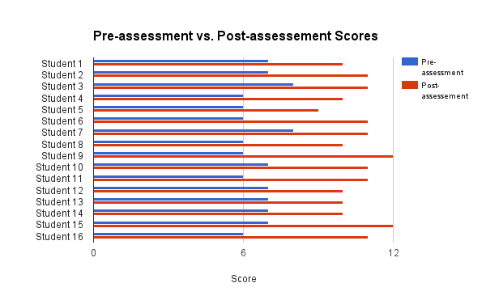
In the graph above we can see improvements across the board and through all areas. In the latter lessons we allowed students to make decisions that directed where the projects would develop. Specifically we voted on our last two projects, this increased the personal investment individual engagement. Though the chart is showing only the total scores for each student on pre and post assessment there were measurable improvements in all areas. The district wide art program uses this rubric to assess all elementary art areas which are Planning and Ideation, Creation and Exploration, and Reflection and Connection. Within those categories students were ranked by advanced, proficient, partially proficient and in progress.

Formative Assessments
With our first grade crew we used the following assessment techniques in our lessons, Targeted questioning and review, pair and share, group reflection, artistic response in the form of a song, reflection/critiques, ticket out the door and video blips (interviews). We also assessed during instruction to make sure students were accessing the content and feeling confident in their processes. Using student reflections we planned our next art experience from their responses. Critiques were often in the form of working critiques so students could use the feedback proactively. Our least successful technique was ‘Ticket out the Door’ because students were not invested in their responses nor did they have a chance to take corrective action. Our most successful technique was targeted questioning and review, because it allowed us to get a feel for where students were in the moment and change directions, give further instruction or model tasks if necessary.

Educator Effectiveness or What Did I Learning About Teaching
My experience at Polaris taught me a huge amount of who I am as an educator and coworker. It felt as if we were pushed out of the nest. We were given lots of guidance, but it was mostly up to us to steer our own learning. In this way, it was like a long experiment. We were able to choose what to teach, make mistakes, gather data, and make the proper adjustments. Not to mention, the community at Polaris couldn’t have been more welcoming. It felt good to come in each Friday and be known as the art teacher. The students were so excited and willing to learn, it was a delight seeing how creative and eager to make they were.
For this reflection, I will go through the Colorado Teacher Quality Standards. I’ll touch on how I’ve grown, what I’ve learned in that area, and how I know that I’ve grown; as well as what went well, what didn’t go well, and what I will do differently in the future.

1. Demonstration of Mastery of Pedagogical Expertise in the Content
Writing lesson plans and delivering them is something that only gets easier with practice. I have learned over these past months that linear thinking is not the right way to approach creating a lesson. If you think in terms of just filling out the boxes, then it will not be cohesive. It’s most beneficial to begin with what students will definitely be learning. It’s a way of thinking that involves focusing on details, as well as keeping the main idea in mind at all times. What are the main learning targets and how can everything else (pre-assessment, inquiry questions, etc.) fit around that? Especially with the first graders we worked with, it was critical that we considered what it actually was we were trying to get across to our students. We had to plan for each question we asked, each transition that was made, each thing written/drawn on the board in order for it all to come together.
There was one lesson where we planned to point out discoveries while students were creating. We had usually gone over them at the end. But this time, we kept a record of the discoveries students were having throughout class. I mostly lead this, and I felt that my initiative and dependability increased by fully following through with what I had planned to do. I feel this is a big part of teaching; following through and not being afraid to screw up. Either way, this exercise gave students more of an ability to learn based off of what they’re classmates we’re learning, which could be considered a scaffolding method.
Integrating numeracy and literacy has become an aspect that I notice is already prevalent in art making. As a teacher, taking those already embedded aspects of literacy and numeracy and making them known to your students is the most effective way of going about it.

>Example: *Detail Activities - We had students record what details they observed, or ideate about details of their creature. In this way, students were using literacy components to talk about details. We brought up the concept of adjectives, and how we use them to describe. Students used adjectives to explain their creature on an ideation sheet

One thing that I should work on in the future is putting more thought into ways for students to respond to their artwork. I usually ask them questions and have them inform me about their work and the process. I could improve this by adding more literacy and numeracy into their reflection activities. For example, having them write a story or numerically rate different components of the finished product and their experience.
Overall, we really focused on allowing the students to create on their own. We wanted them to feel that their art making was personal to them. We could have done better providing art experiences that are clear. There were some lessons that ended slightly contrary to how we planned, which was a result of us not being clear with what we expected. This got easier over time once we began to make things simpler.

2. Safe, Inclusive, and Respectful Learning Environment
As the teacher, you hold the power to provide equitable experiences for each of your students. Specifically, as an art teacher, it’s my job to push students to further their thoughts and develop higher ways of thinking through art making. I’ve come to realize more so that each student has a unique and special way of thinking. I’ve grown with my ability to harness those individual ways of problem solving, understanding, and approaching a task of each student. It’s a delicate balance of allowing students to create and learn on their own time, but stepping in when you need to.

>Example: *Recognizing personal engagement – One student from Polaris always appeared to have a harder time grasping on to the concepts we introduced and what was expected of him. There was one activity that we did involving creating new colors with watercolor. He wasn’t as organized as other students, and, without knowing him and his abilities, it would appear that he was just being messy and reckless. I came to the conclusion that he was learning just as much as all the other students, maybe even more. He was making numerous connections through play, and it was logical to let him keep going.

One of my main goals with teaching has to do with creating a safe environment for self-expression. There’s so much value in being comfortable with who you are and what you can bring to the world. During my time at Polaris, I really strove to point out personal achievements. We had a couple reflection activities that involved sharing your work. For the future, I would implement an activity that has to do with learning respect for yourself and other classmates. It would involve being learning about how we’re all different, and being different is good.
At times, we had difficulty providing all of the materials during class so things would go smoothly. This stemmed directly from lack of planning in instruction. We learned after 3 or 4 times, that we needed to plan when and how we would give students their materials to work with; as well as be completely prepared before teaching. Otherwise, not as many tasks get completed, and there’s a sense of chaos in the room.
Things can get stressful in a classroom, especially when you’re new to teaching. But it’s important to keep your whit about you and demonstrate ethical behavior and integrity. Rising above stress and being an example for your students provides a role model for them, as well creates a mutual respect.

3. Plan and Deliver Effective Instruction
Instruction is where the pre-assessment, objectives, ideation, etc. come together and play out in the classroom. It’s a way of translating your intentions of the lesson into an actual step-by-step plan. My group and I grew a good amount in regard to how to present information to students. We began with vaguely introducing what we were going to do for the day, then letting them loose. This resulted in the students not quite taking away what we intended from the lesson. It was imminent that we had to simplify instruction and make it clear what we would be accomplishing from the day. We began to ask the students what they know or see, rather than tell them what they should know.

>Example: *What do you know? – There was one power point that we presented to introduce the concept of sketchbooks. It had a good amount of information on each slide about the history, how they can be used, etc. You could tell that our students understood most of it, but didn’t quite comprehend the information to the point that they would be able to make their own inferential connections. The next power point that we made was mostly pictures, and we had the students figure out what was going on in each slide by asking about what they know, how they know, etc.

Set your students up for success. This was a big thing that I learned from Polaris. It involves you, as the teacher being clear with what will be taught, as well as making it clear to students. For first grade, it worked to have usually one or two objectives for the day on the board and having everything else follow. For example, one of our objectives was “understand the components of a 3D shape.” We spent most of class talking about the difference between 2D and 3D. I was the lead teacher, and I demonstrated creating a 2D shape on the board, then modeling it with clay. Once it was clear that students understood, we set them free to explore the clay. During this class period, I had a bit of trouble using my tact and judgment. I presented students with an ideation sheet that involved drawing 4 shapes, then creating those shapes with clay. I wanted to give the opportunity simply play with the clay, but also knew I needed to integrate some sort of ideation. After the class was over, I realized I should have let students play to get excited about clay. Then about halfway through, I should’ve handed out the ideation sheet to give them something a bit more structured and challenging. These are the “experiments” that I spoke of before. I wasn’t sure how to approach this lesson, but after teaching it my tact and judgment increased. I now know that it’s okay to change up the lesson halfway through class after monitoring student progress.
A big thing that I intend improve on in the future is increasing my ability to communicate to students. I think part of this will come with experience, learning what to say in certain situations. But overall, it concerns manipulating students to consider the larger premise of what they’re working on.

4. Reflection of Practice
Reflecting on an experience and drawing conclusions from data is how the human brain moves forward. In teaching, the educator must know where their students are at with what is being taught. I learned that it’s easy to simply give what you know and expect students to receive it, but you must be sure that they’re receiving it. Documenting what students say about their creations shows their thought process and their ability to make connections. I also really enjoyed doing journal responses. Looking back on them now allows me to bring everything together, and see my progression. This is something that I will definitely continue in the future, for the therapeutic and logical reasons.
I realized that when I was taking a video of a student speaking about their art, it was important for me to maintain eye contact and be in the moment. It felt like I was just concerned about getting documentation, rather than really hearing what they have to say and responding as an effective communicatory. So in the future, I will be more subtle with collecting data.
I really learned the most when reflecting on my own performance. Hearing the feedback from our host teachers and discussing with my group members about what went well and what didn’t go well, really bestowed me to want to improve.

5. Demonstration of Leadership
There’s a common misconception of the term “leader.” It seems that people think there can only be one. This is not true. Even with students, a lot of times the ones that go unseen are the ones that have the most dependability and character. This last semester at Polaris taught me a lot about how I contribute in a group setting. It wasn’t easy working with people that all have somewhat different perspectives and ideas. But I learned to hear each of my members out and remain rhetorical in my stance. I continued to learn when my word was useful, as well as my dependability as a group member. Contributing to that sort of situation requires a good amount of effort from each member to bring what they can, and learn to work together.
This semester more than many others made me realize my will to become an art teacher. I’ve always had trouble committing myself to things that I couldn’t fully connect to. But the hard work and thought that went behind each lesson was incredibly rewarding and I strove to get better each time. I feel that I grew in almost every area of the dispositions. My professional behavior towards teaching grew because I felt truly committed. I can always continue to work on each of these every time I teach.

